JV Upload Cannot Delete from “Authorize Bulk File Upload” In T24:

Delete File

File upload Details for Authorize or Delete:

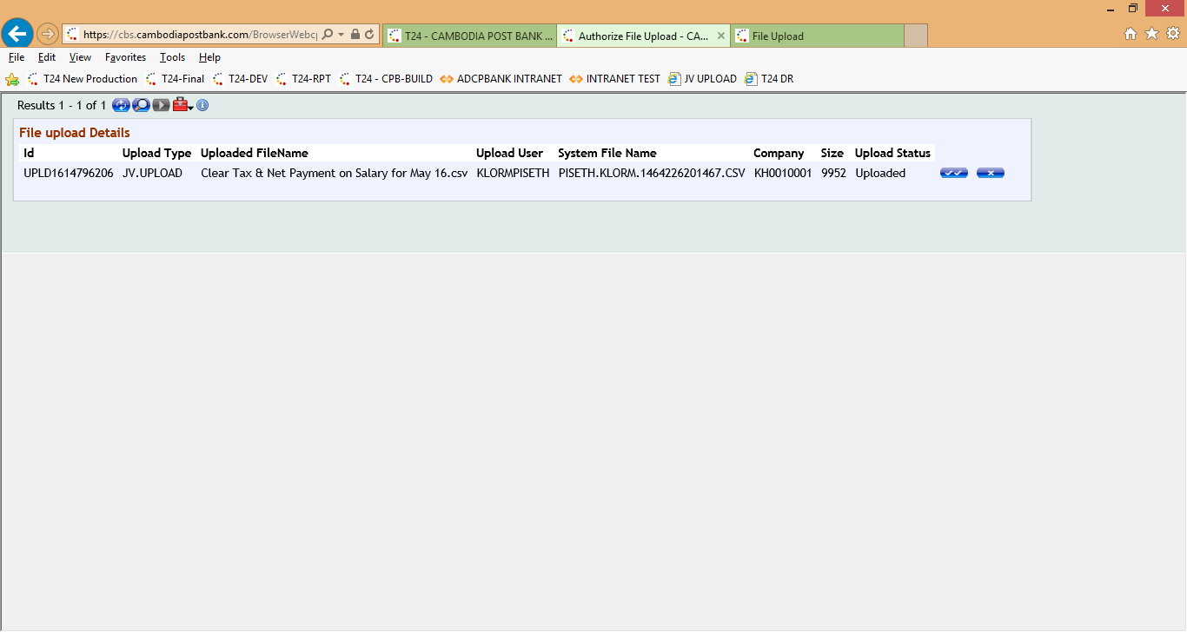

File upload cannot delete with the below message:

